Key Topics
Azure Interaction Methods
  - Azure Portal (graphical, intuitive, good for learning but not recommended for production).
  - Command-line tools: PowerShell, Azure CLI for automation and scripting.
  - Templates (declarative): ARM templates (JSON), Bicep, Terraform (third-party).
  - All resource management requests go through Azure Resource Manager (ARM) REST API.

Control Plane vs Data Plane
  - Control Plane: Manages and interact with Azure resource itself (create, delete, modify).
  - Data Plane: Manages the data inside resources (e.g., blobs, database tables).
  - Permissions for control plane and data plane are distinct; access to one does not grant access to the other.
  - Azure supports Role-Based Access Control (RBAC) on both planes, but data plane RBAC varies by service.

Cloud Service Layers & Responsibility Models
  - Infrastructure as a Service (IaaS): User manages OS, database software, patching, backups, tuning.
  - Platform as a Service (PaaS): Azure manages OS, runtime, middleware, database engine; users focus on app and data.
  - PaaS benefits: evergreen updates, auto backup, high availability, auto-scale, less operational burden.
  - PaaS examples: Azure SQL Database, Azure SQL Managed Instances, and managed databases like PostgreSQL, MySQL.

- Networking & Access
  - Databases and services have DNS names requiring resolution.
  - Access via public endpoints or private endpoints within virtual networks.
  - Connectivity may require VPN, ExpressRoute, or other network solutions.
  - Authentication and authorization (Azure AD, keys, SAS tokens) are essential for data access.

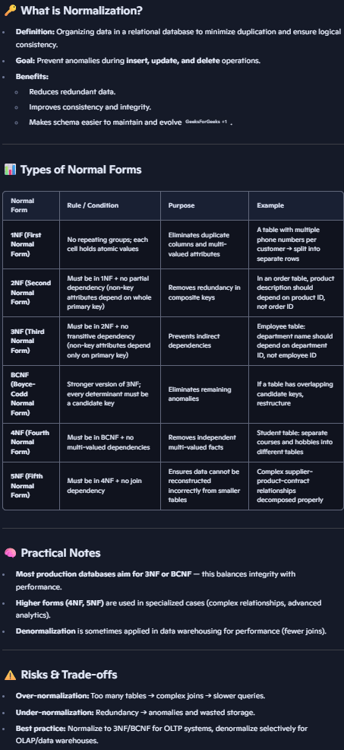
Types of Data
  - Structured Data: Fixed schema, well-defined entities, normalized relational databases.
    - Tables with columns (attributes) and rows (records).
    - Primary keys and foreign keys enforce data integrity and relationships.
    - Examples: SQL Server, Azure SQL Database, PostgreSQL, MySQL.
  - Semi-Structured Data: Flexible schema, self-describing formats like JSON, XML, CSV.
    - Supports arrays and variable attributes.
    - Used in document databases and data lakes.
  - Unstructured Data: No schema, binary large objects (BLOBs) such as images, videos, documents.
    - Stored typically in Azure Blob Storage.
  - Other Data Types:
    - Graph: Nodes and edges representing relationships (e.g., social networks).
    - Key-Value: Simple key and value pairs (e.g., Azure Table Storage).
    - Time Series: Data organized by time, for telemetry and logs.

Data Type | Characteristics | Azure Examples
Structured | Fixed schema, relational, normalized | Azure SQL DB, PostgreSQL, MySQL
Semi-Structured | Flexible schema, JSON, XML, CSV | Cosmos DB (document), Data Lake
Unstructured | No schema, binary files, media | Azure Blob Storage
Graph | Entities + Relationships (nodes/edges) | Cosmos DB (Gremlin API)
Key-Value | Simple key and value pairs | Azure Table Storage
Time Series | Time-indexed data | Azure Time Series Insights

Azure Storage Account Services
  - Blob Storage types: Block Blob (large files), Page Blob (random read/write, used for disks), Append Blob (append-only, e.g., logs).
  - Azure Data Lake Storage Gen2: Built on blob, adds hierarchical namespace, POSIX-like access, optimized for analytics.
  - Azure Files: SMB and NFS file shares, hybrid syncing with Azure File Sync.
  - Other services: Queues (message passing), Tables (key-value).

Storage Redundancy & Performance Tiers
Redundancy Options:
    - LRS (Locally Redundant Storage): 3 copies in one data center.
    - ZRS (Zone-Redundant Storage): 3 copies across availability zones.
    - GRS (Geo-Redundant Storage): LRS + async replication to paired region.
    - GZRS (Geo-Zone-Redundant Storage): ZRS + async replication to paired region.
  - Read Access options (RA-GRS, RA-GZRS) allow read from secondary region for blobs, queues, tables.
Performance tiers (only block blob):
    - Premium: Low latency, high performance, higher cost.
    - Standard: Hot, Cool, Archive tiers with varying cost and access latency.
  - Lifecycle Management automates moving data between tiers based on access patterns.
Storage Tier | Capacity Cost (per GB) | Transaction Cost Trend | Latency | Use Case
Premium | Highest ($0.15/GB) | Lowest | Lowest (fastest) | High performance needs
Hot (Standard) | Medium (~$0.018/GB) | Medium | Standard | Frequently accessed data
Cool (Standard) | Lower (~$0.01/GB) | Higher | Higher latency | Infrequently accessed data
Archive | Lowest (~$0.00099/GB) | Highest (rehydration) | Very high latency | Long-term archival, offline

Data Workloads and Database Types
  - OLTP (Online Transactional Processing): High volume of small transactions, Focus on transactional integrity, normalized schema, fast reads/writes.
    - Example services: Azure SQL Database, PostgreSQL, MySQL.
    - Emphasis on ACID properties: Atomicity, Consistency, Isolation, Durability.
  - OLAP (Online Analytical Processing): Large data volumes, mainly historical data, denormalized schema, read-heavy for analytics/reporting.
    - Example service: Azure Synapse Analytics (Data Warehouse).
    - Supports complex analytical queries, integrates tightly with Data Lake.

Roles in Data Ecosystem
  - Database Administrator (DBA): Designs, implements, and maintains databases; manages schema, indexes, performance, backups.
  - Data Engineer: Understands data workload. Designs data pipelines; ingests, transforms, and loads data; responsible for data flow and infrastructure.
  - Data Analyst: Explores data, finds relationships, builds models, extracts business insights, visualises data.

SQL and Database Interaction
  - Relational databases use SQL (Structured Query Language) with subsets:
    - DDL (Data Definition Language): Create/alter/drop schemas & objects (Table, Stored procedure, view)
    - DCL (Data Control Language): Manage permissions. Grant, deny, revoke
    - DML (Data Manipulation Language): Insert, update, delete data.
    - DQL (Data Query Language): Select/queries.
  - Common SQL features: joins, indexes, stored procedures, views.
  - Azure SQL Database supports multiple service tiers: General Purpose, Business Critical, Hyperscale; offers elastic pools and serverless options.
  - Azure SQL Managed Instance offers near 100% compatibility with on-premises SQL Server and deploys inside customer VNet.
  - SQL Server can also be run in IaaS Azure VMs with varying management levels.

Other Managed Database Services
  - Azure Database for PostgreSQL: Single server, flexible server, hyperscale options.
  - Azure Database for MySQL: Single server and flexible server.
  - Azure Database for MariaDB: Single server.
  - Azure Managed Apache Cassandra: Automated scaling, hybrid deployment.

Cosmos DB: Globally Distributed Multi-Model Database
  - Designed for cloud-native multi-region writes and flexible consistency.
  - Supports multiple APIs: SQL, MongoDB, Cassandra, Tables, Gremlin (graph).
  - Consistency levels: Strong, Bounded Staleness, Session, Consistent Prefix, Eventual.
  - Pricing based on Request Units (RUs); supports provisioned (fixed request units), autoscale (min and max request units, modified dynamically, common but slightly expensive), and serverless (for small scale workloads) modes.

Big Data & Analytics Services
Azure Synapse Analytics: Combines data warehousing, big data analytics, Apache Spark, and pipelines. Separates compute and storage. Can pause compute to save costs.
Azure Data Factory: Orchestration service for data workflows. Source --> Sink
    - Manages control flow of ETL/ELT pipelines.
    - Supports scheduling, event triggers (schedule/manual/event), and hybrid data sources.
Transforming data can be something simple like “Mapping” (can be done by data factory itself) or complex transformations for which we data factory utilises below 2:
  - Azure Databricks: Managed Apache Spark platform for big data analytics and collaboration.
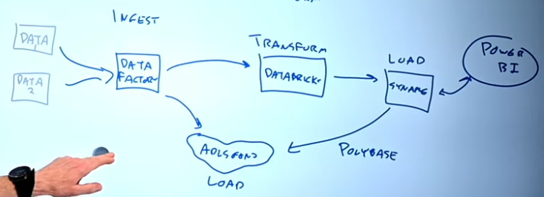
  - Azure HDInsight: Managed clusters for Apache open-source data processing (Spark, Hadoop, Kafka, Storm).

Azure Data Explorer: Used If the data is logs/telemetry - analytics using Kusto Query Language (KQL).
Data Ingestion and Processing Patterns
  - Batch Processing: Data collected in group, Large volumes, interval-based, higher latency.
  - Streaming Processing: Real-time or near real-time, low latency, high scale. Azure stream analytics.
    - ETL: Extract, Transform, Load. (can’t come back to original data as it was loaded after transforming, so if we wanted something from that data now, we dont have it)
    - ELT: Extract, Load Raw Data, Transform Later (common with cheap storage like ADLS gen2).
Schema-on-read vs Schema-on-write:
    - Schema-on-write: Data is transformed into a fixed schema before storage.
    - Schema-on-read: Schema applied dynamically during query, slower but flexible.

Visualization & Business Intelligence
  - Power BI: Desktop and cloud-based service for data modeling, visualization, and interactive dashboards.
  - Supports multiple data sources: Data Lake, Data Warehouse, Excel, SaaS.
  - Enables different types of analytics: descriptive (what happened), diagnostic (why), predictive (will), prescriptive (what to do), and cognitive (conclusions based on existing knowledge).

Data Governance with Microsoft Purview
  - Provides data discovery, classification, and governance across multi-cloud and on-premises.
  - Supports in-place scanning (no data copying).
  - Classifications include PII, HIPAA, and custom classifiers using machine learning.
  - Enables data lineage, risk management, access controls, and compliance enforcement.

Core Concepts & Definitions Table
Concept | Description
Control Plane | Resource management layer in Azure (create, update, delete resources).
Data Plane | Data access layer inside resources (e.g., blobs, tables, queues).
IaaS | Cloud service model where user manages OS and applications.
PaaS | Cloud service model where platform services are managed by Azure, user focuses on data/app.
OLTP | Online Transaction Processing; transactional, normalized, ACID compliant.
OLAP | Online Analytical Processing; analytical, denormalized, read-heavy.
Cosmos DB Consistency | Five levels from Strong to Eventual; trade-off between latency and consistency.
Request Units (RUs) | Cosmos DB throughput currency; governs cost and performance.
Lifecycle Management | Automated movement of data between storage tiers based on access patterns.
Private Endpoint | Network interface within VNet providing private access to Azure PaaS services.
ELT | Extract, Load raw data, Transform later; enables flexibility with data lakes.
Schema-on-Read | Schema applied when data is read rather than when written; allows for flexible data formats.

